SDG4: QUALITY EDUCATION

The aim of this documentation is to provide a comprehensive analysis of the high dropout rates in secondary schools, particularly in rural areas, and propose data-driven solutions to address this issue. It outlines the relationship between resource availability, such as libraries and computer labs, and educational outcomes, while highlighting the importance of targeted interventions to promote equal access to quality education.

**Problem it is Trying to Solve:**

The documentation addresses the problem of **high dropout rates** in secondary schools, especially in rural areas where access to essential educational resources is limited. These disparities contribute to poor academic performance and reduced opportunities for students, hindering efforts to achieve **SDG 4: Quality Education for All**. The project seeks to bridge this gap through data analysis, resource allocation, and strategic partnerships.

The SQL scripts

CREATE TABLE SchoolOverview (

SchoolID INT PRIMARY KEY,

SchoolName VARCHAR(100),

Location VARCHAR(50),

TotalStudents INT,

TotalTeachers INT,

Classrooms INT,

ComputerLabs INT,

Libraries INT,

SportsFacilities INT,

TotalComputers INT,

InternetAccess VARCHAR(3),

DropoutRate DECIMAL(5,2),

AvgExamScore DECIMAL(5,2),

AvgAttendance DECIMAL(5,2),

TotalBooks INT,

TotalTablets INT,

TotalProjectors INT

);

INSERT INTO SchoolOverview (SchoolID, SchoolName, Location, TotalStudents, TotalTeachers, Classrooms, ComputerLabs, Libraries, SportsFacilities, TotalComputers, InternetAccess, DropoutRate, AvgExamScore, AvgAttendance, TotalBooks, TotalTablets, TotalProjectors)

VALUES

(1, 'Greenfield High', 'Rural', 500, 25, 15, 1, 1, 1, 50, 'Yes', 0.10, 72.5, 77.5, 2000, 50, 1),

(2, 'Urban Central School', 'Urban', 600, 40, 20, 2, 1, 1, 100, 'Yes', 0.05, 92.5, 76.0, 3000, 100, 2),

(3, 'Lakeside Academy', 'Rural', 450, 20, 12, 0, 1, 0, 20, 'No', 0.20, 55.0, 67.5, 1000, 20, 0),

(4, 'Mountainview School', 'Rural', 350, 18, 10, 0, 1, 1, 15, 'No', 0.15, 60.0, 70.0, 800, 10, 0),

(5, 'Sunrise Secondary', 'Urban', 700, 45, 25, 3, 1, 1, 120, 'Yes', 0.07, 85.0, 82.0, 3500, 120, 3),

(6, 'Riverbend High', 'Rural', 400, 22, 14, 0, 1, 0, 10, 'No', 0.25, 50.0, 60.0, 900, 15, 0),

(7, 'Harborview Secondary', 'Urban', 650, 35, 18, 2, 1, 1, 90, 'Yes', 0.12, 80.0, 75.0, 2800, 80, 2),

(8, 'Hilltop Academy', 'Rural', 500, 28, 16, 0, 1, 1, 30, 'No', 0.18, 65.0, 68.0, 1500, 25, 1),

(9, 'Coastline School', 'Urban', 600, 38, 22, 2, 1, 1, 85, 'Yes', 0.09, 88.0, 80.0, 2900, 90, 2),

(10, 'Foresthill High', 'Rural', 450, 25, 15, 0, 1, 0, 25, 'No', 0.22, 58.0, 62.5, 1100, 20, 0);

**ENTITY RELATIONSHIP DIAGRAM**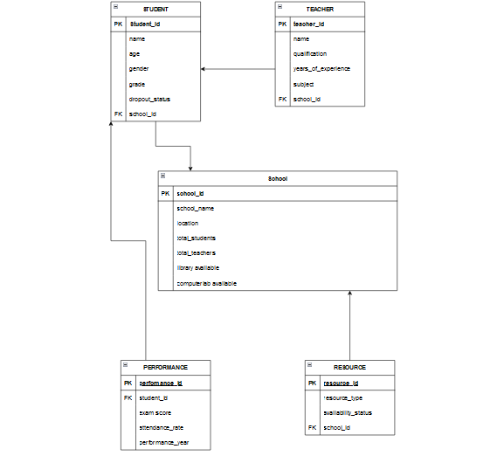

**PITCH DECK**

Provided is the link for the Presentation : https://gamma.app/docs/Unlocking-Educational-Equity-Data-Driven-Solutions-for-SDG4-xaqs7dc54ro2dmw?mode=doc